**PROJECT REPORT**

**DCN LAB**

**HAFIZ AHMAD ALI 01-134222-051**

**MUHAMMAD UMAIS 01-134221-055**

**Data Networking Between Two Campuses**

**Abstract**

This report details the implementation of a data networking project aimed at establishing a robust and efficient network between two campuses. The key concepts and technologies involved include VLAN Trunking Protocol (VTP), Virtual Local Area Networks (VLANs), Routing Information Protocol (RIP), and Dynamic Host Configuration Protocol (DHCP). These technologies are utilized to ensure seamless communication, efficient routing, and dynamic IP address allocation across the campuses.

**Introduction**

With the increasing need for reliable and efficient communication between geographically separated campuses, this project focuses on designing and implementing a network infrastructure that ensures high performance, scalability, and ease of management. The two campuses in question require a network setup that can support diverse applications, services, and user requirements. The project leverages VTP, VLAN, RIP, and DHCP to create a scalable and manageable network environment.

**Objectives**

* To establish a reliable and efficient data network between two campuses.
* To segment network traffic using VLANs for improved performance and security.
* To implement VTP for centralized VLAN management.
* To use RIP for efficient routing between the campuses.
* To set up DHCP for dynamic IP address allocation.

**Network Design**

**VLAN and VTP Implementation**

VLANs are employed to segment network traffic logically. This segmentation helps in isolating broadcast domains, improving network performance, and enhancing security. VTP is used to manage VLAN configurations across multiple switches from a central point, reducing administrative overhead.

* **VLAN Configuration**: VLANs are created for different departments and services such as Administration, Academics, Guest Network, and IT Support.
* **VTP Configuration**: A VTP domain named "CampusNet" is created. One switch is configured as the VTP server, and all other switches are set as VTP clients. This ensures that any VLAN configuration changes made on the server are propagated to all client switches.

**RIP Configuration**

RIP is utilized to facilitate routing between the two campuses. Each campus has its own local network, and RIP helps in maintaining routing tables dynamically, allowing for efficient data transfer across the network.

* **RIP Setup**:
  + The routers in each campus are configured to use RIP.
  + Network statements are added to include the local networks of each campus.
  + Periodic updates ensure that routing tables are maintained and up-to-date.

**DHCP Implementation**

DHCP is crucial for the dynamic allocation of IP addresses to devices within the network. This simplifies network administration and ensures that IP address management is efficient.

* **DHCP Configuration**:
  + DHCP servers are set up in each campus to allocate IP addresses dynamically.
  + Different IP address pools are configured for each VLAN.
  + Additional DHCP options such as default gateway, DNS servers, and lease time are specified.

**Testing and Validation**

1. **VLAN Functionality**: Verify that devices within the same VLAN can communicate with each other and are isolated from other VLANs.
2. **VTP Propagation**: Ensure that VLAN configurations made on the VTP server are propagated to all VTP client switches.
3. **RIP Routing**: Check routing tables on routers to confirm that RIP updates are being received and correct routes are established.
4. **DHCP Allocation**: Validate that devices receive correct IP addresses from the DHCP server and can access network resources.

**Conclusion**

The project successfully demonstrates the implementation of a comprehensive data networking solution between two campuses using VTP, VLAN, RIP, and DHCP. The use of VLANs ensures effective network segmentation, VTP simplifies VLAN management, RIP provides dynamic routing, and DHCP automates IP address allocation. This setup not only enhances network performance and security but also simplifies network administration.

**Structure :**

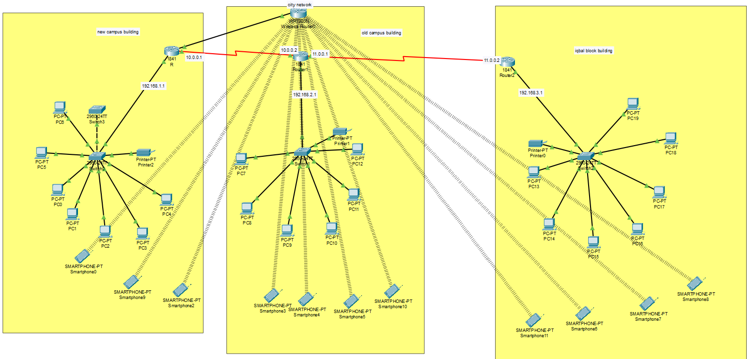

**References**

* Cisco Systems, "Configuring VLANs," Cisco Documentation.
* Cisco Systems, "Configuring VTP," Cisco Documentation.
* RFC 2453, "RIP Version 2," IETF.
* RFC 2131, "Dynamic Host Configuration Protocol," IETF.

Top of Form

Bottom of Form